User Instruction

In the main question list page, users can view question lists from 3 different levels and deactivated questions by clicking on different tabs. You can add a new question by simply clicking on the “Add a new question” button.

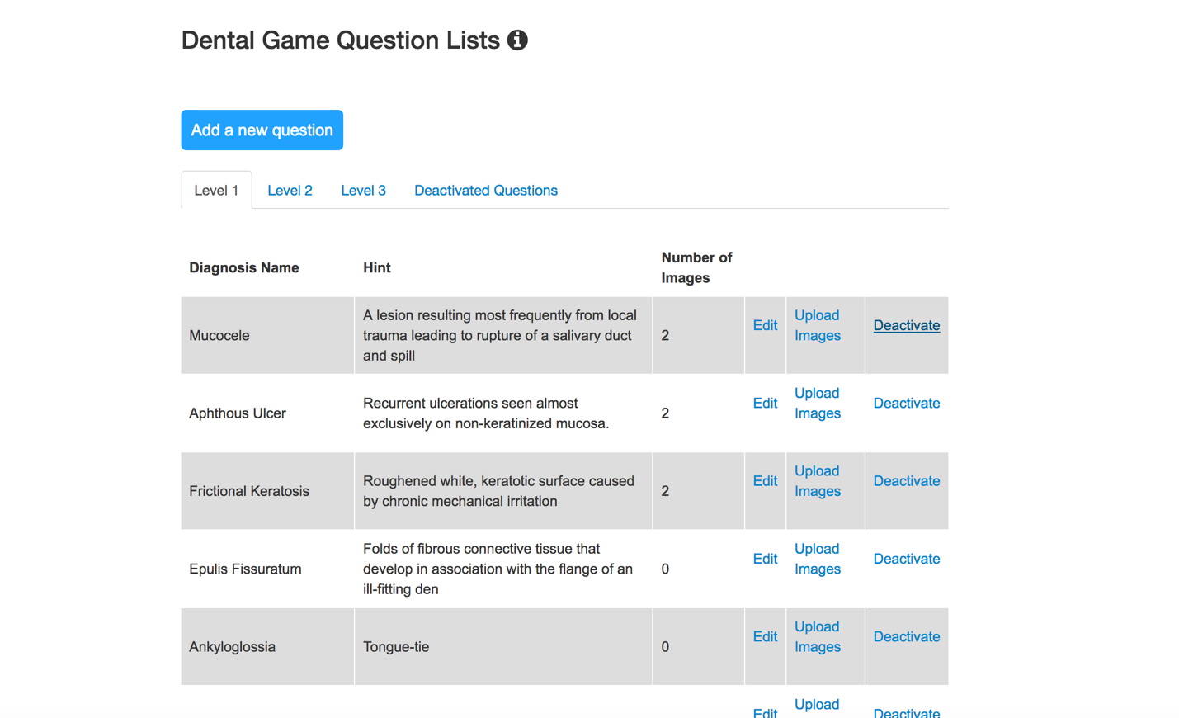

1. Adding new questions

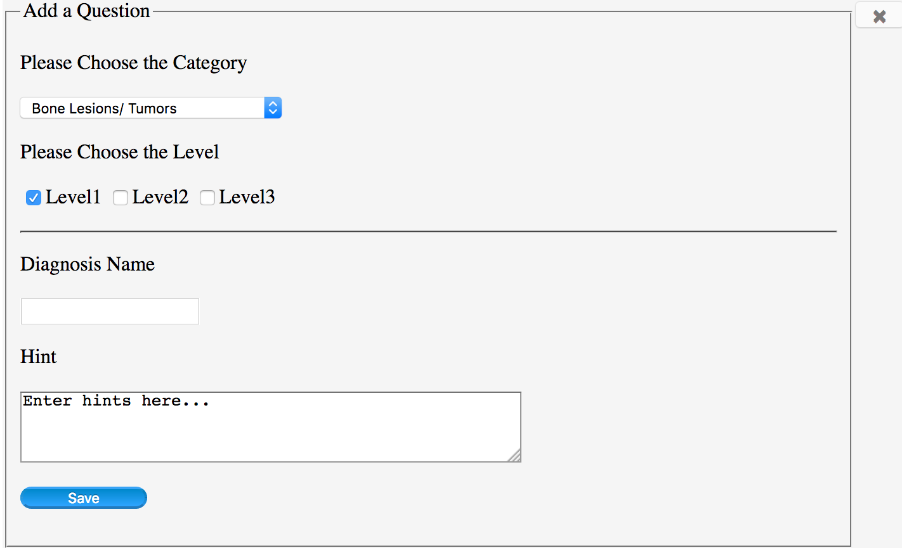

Users can choose a category, levels which the added question belongs to, users can also input a diagnosis name and the hint.

1. The default value of category Bone Lesions/Tumors and the default value of Level is level 1.

2. Users cannot leave the diagnosis name field empty.

3. Users cannot input a diagnosis name that already exists.

4. Hint field can be empty, and users can edit the hint later.

5. By clicking the “Save” button, users can submit a new question.

6. By clicking the “x” button in the top right of the form, users can back to question lists.

After save the basic information of the question, users can upload an image.

The requirements of the image include:

1. Users cannot upload same images repeatedly.

2. Users cannot upload images that are too large;

3. Users can only upload JPG, JPEG, PNG & GIF files.

After users upload an image, they can choose to back to question lists or add another image.

Any updated would show in the question list page.

2. Edit questions

Users can edit questions by clicking the “edit” after each question.

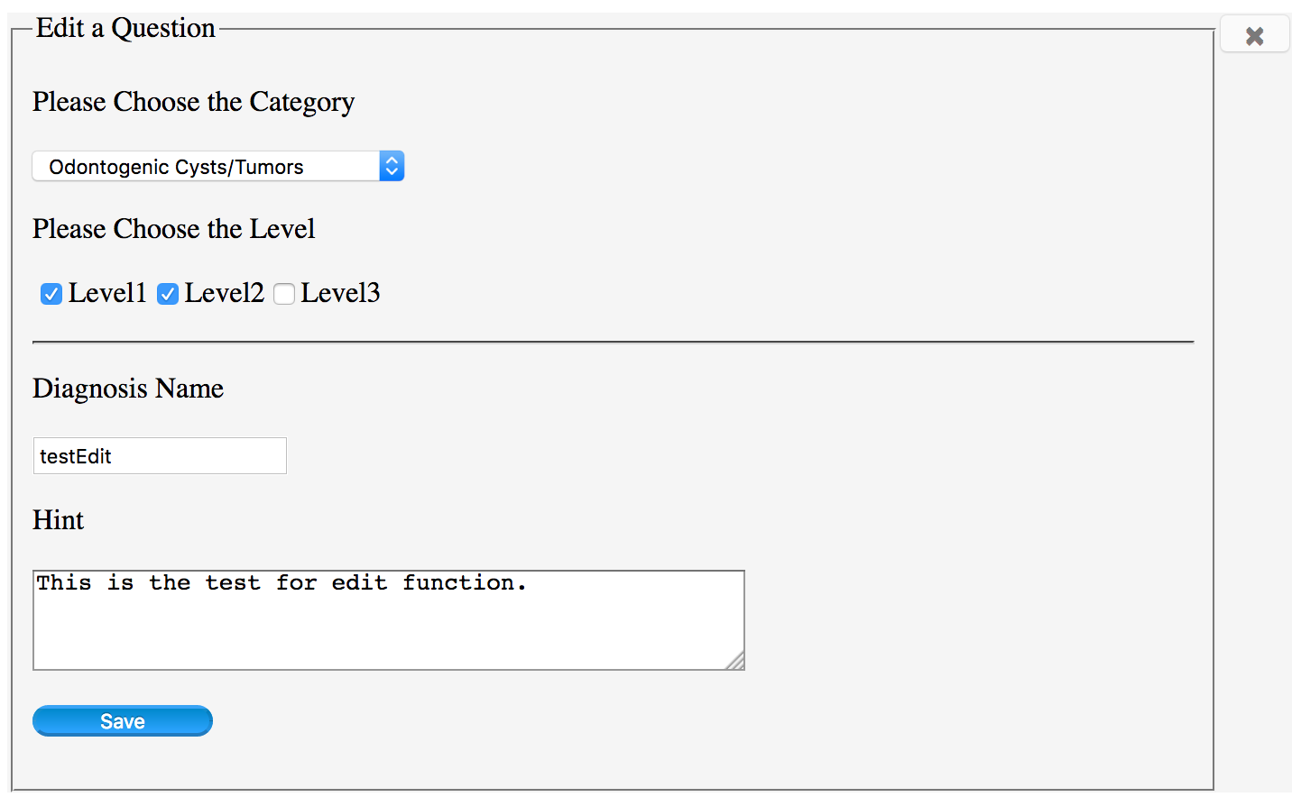

Users can edit category, levels, diagnosis name, and hint of the selected question.

1. The default values would be the original information of the selected question.

2. Users cannot leave the diagnosis name field empty.

3. Users cannot input a diagnosis name that already exists except that the selected diagnosis name keeps unchanged.

5. By clicking the “Save” button, users can update their edits.

6. By clicking the “x” button in the top right of the form, users can back to question lists.

3. Upload images

Users can also upload new images through the link after each question, other operations would be the same with the image uploading when adding a new question.

4. Deactivate questions

Questions would not be really deleted, by simply clicking the “Deactivate” after each question, the question would be deactivated and it would be moved to the deactivated question list.

5. Activate questions

Questions could be activated again by simply clicking the “Activate” link. Reactivated questions would show in the level lists again.